# Homework: Working with User Input

This document defines homework assignments from the [“PHP & MySQL“ Course @ Software University](https://softuni.bg/trainings/fasttracks/details/1033). Please submit as homework a single zip / 7z archive holding the solutions (source code) of all below described problems.

## Web Page

Create a login menu as shown below. The menu should allow a new user to registration or a already member to sing in. The submitted information should be export to a text file. Examples of site:

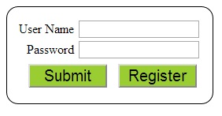

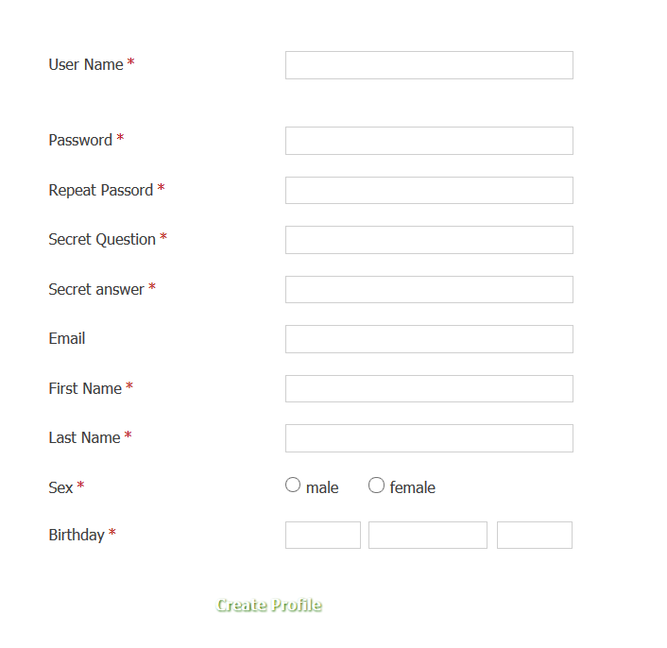

## Edit Profile

(Continuing task 1) add option user to be able to edit his own submitted information.

## *Search Users

(Continuing task 1) add option to search user by name and visualize information.

## *Add Picture

(Continuing task 1) add option user to be able to add or change profile picture.